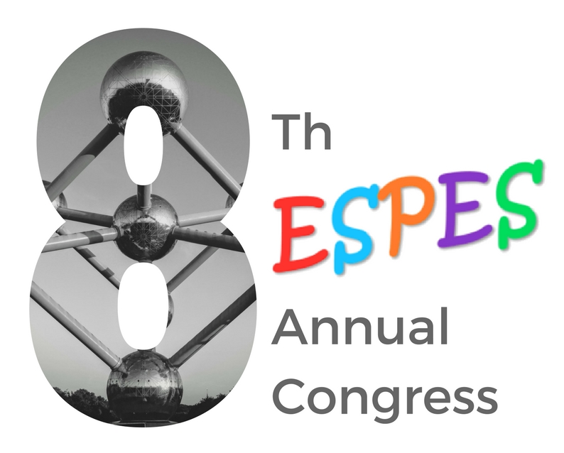

European Society of Paediatric
Endoscopic Surgeons

SEPTEMBER 26TH - 28TH, 2018
LE PLAZA – BRUSSELS, BELGIUM

Dear Colleagues,
On behalf of the European Society of Paediatric Endoscopic Surgeons (ESPES) we have the honor and great pleasure to invite you to the 8th Annual Congress of our Society that will be held in Brussels, Belgium.
Our Society interests more and more surgeons all over Europe and even elsewhere. This would say that ESPES has proven to have important impact for paediatric endoscopic surgery development. Our annual Congress is the ideal place for exchanging and sharing our experience, listen to expert opinions, participate in round tables and, last but not least, look for new collaborations and friendships.
We will try to make from this 8th Congress an outstanding scientific and social experience. We are very much looking forward to receiving many interesting papers and to establish an exciting program. Several National Endoscopic Societies will join the pre-congress program and this is fantastic news because attendees will participate in colorful topics from over Europe!
And finally there is Brussels: “With a child peeing as a tourist symbol, and famous for its French fries and waffles, it manages to create a nice balance in between the seriousness brought to it by the European institutions and the entertaining aspects it surprises you with daily.
A complete and appropriate conclusion would be: Brussels helps you to open your mind.”
We are delighted to have you as hosts in Brussels between 26 and 28 of September 2018.
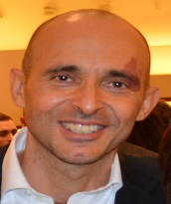

Ciro Esposito
ESPES President

Henri Steyaert
Congress chairman

Paul Philippe
Congress co-chair

Time | Wed 26.09.2018 |  |  | Thu 27.09.2018 |  |  | Fri 28.09. 2018
8.00 8.30 |  |  |  | Scientific Sessions I-II |  |  | Scientific Sessions VI-VII
8.30 9.00 | Master Class robotic surgery with live demonstration and simulator training | Workshop “learning different trying methods” + Paediatric models training | Advanced Urology Course Expert panel; exercises on virtual models
9.00 9.30
9.30 10.00
10.00 10.30
10.30 11.00 |  |  |  | Coffee break and Commercial exhibition |  |  | Coffee break and Commercial exhibition
11.00 11.30 |  |  |  | Scientific Sessions III-IV |  |  | Keynote Lecture
11.30 12.00 |  |  |  |  |  |  | Experts – attendees. Difficult cases: how to manage?
12.00 12.30
12.30 13.10 |  |  |  |  |  |  | Scientific Sessions VIII  + Take Home Messages
13.10 13.15 |  |  |  | + Take Home Messages
13.15 13.30 |  |  |  | ESPES President Address
13.30 14.30 |  |  |  | Lunch and commercial exhibition | Poster Session |  | Lunch and commercial exhibition | Poster Session
 |  |  |  |  |  | Commercial Presentation |  |  | Commercial Presentation
 |  |  |  |  |  |  | Meet the Expert Lunch Morbid obesity surgery in children: new evolutions
14.30 15.00 | National Meetings:  SIVI (Italy),  GECI (France),  RSPLS (Romania),  Belgian, Dutch and Swiss group,  Polish Paediatric Surgeons Group, Maghreb Paediatric Surgeons Group, Spanish Paediatric Surgeons Group |  |  | Keynote lecture  Prof. El Ghoneimi (Paris) |  |  | Scientific Session IX
15.00 15.30 |  |  |  | Round Table debate: “Thoracoscopic Surgery: combining surgical and anesthetic goals”
15.30 16.00 |  |  |  |  |  |  | Round Table: “Emerging technologies: where are we going?”
16.00 16.30 |  |  |  | Coffee break and Commercial exhibition
16.30 17.00 |  |  |  | Scientific Session V |  |  | Scientific session X
17.00 17.30
17.30 18.00 |  |  |  |  |  |  | ESPES Awards – Closing Remarks
18.00 18.30 |  |  |  | ESPES General Assembly
20.00 Evening Event | Inaugural Act, ESPES Welcome reception |  |  | ESPES GALA EVENING

ABSTRACT SUBMISSION AND REGISTRATION ARE OPEN!
Visit our website : www.espes.eu

WITH THE SUPPORT OF

